**SPH3U 13.3 Alternating Current**

1. **Alternating current**

|  |  |
| --- | --- |
| Continuous current: |  |
| solution |  |
| Alternating current: |  |
| DC vs. AC: |  |
| Canada’s electricity: |  |
| RMS voltage: |  |

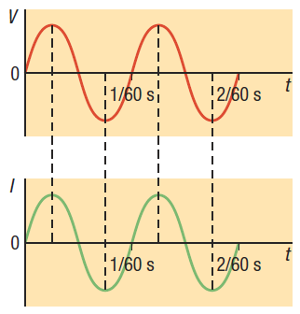

**Homework:** page 598: #1-2, 5